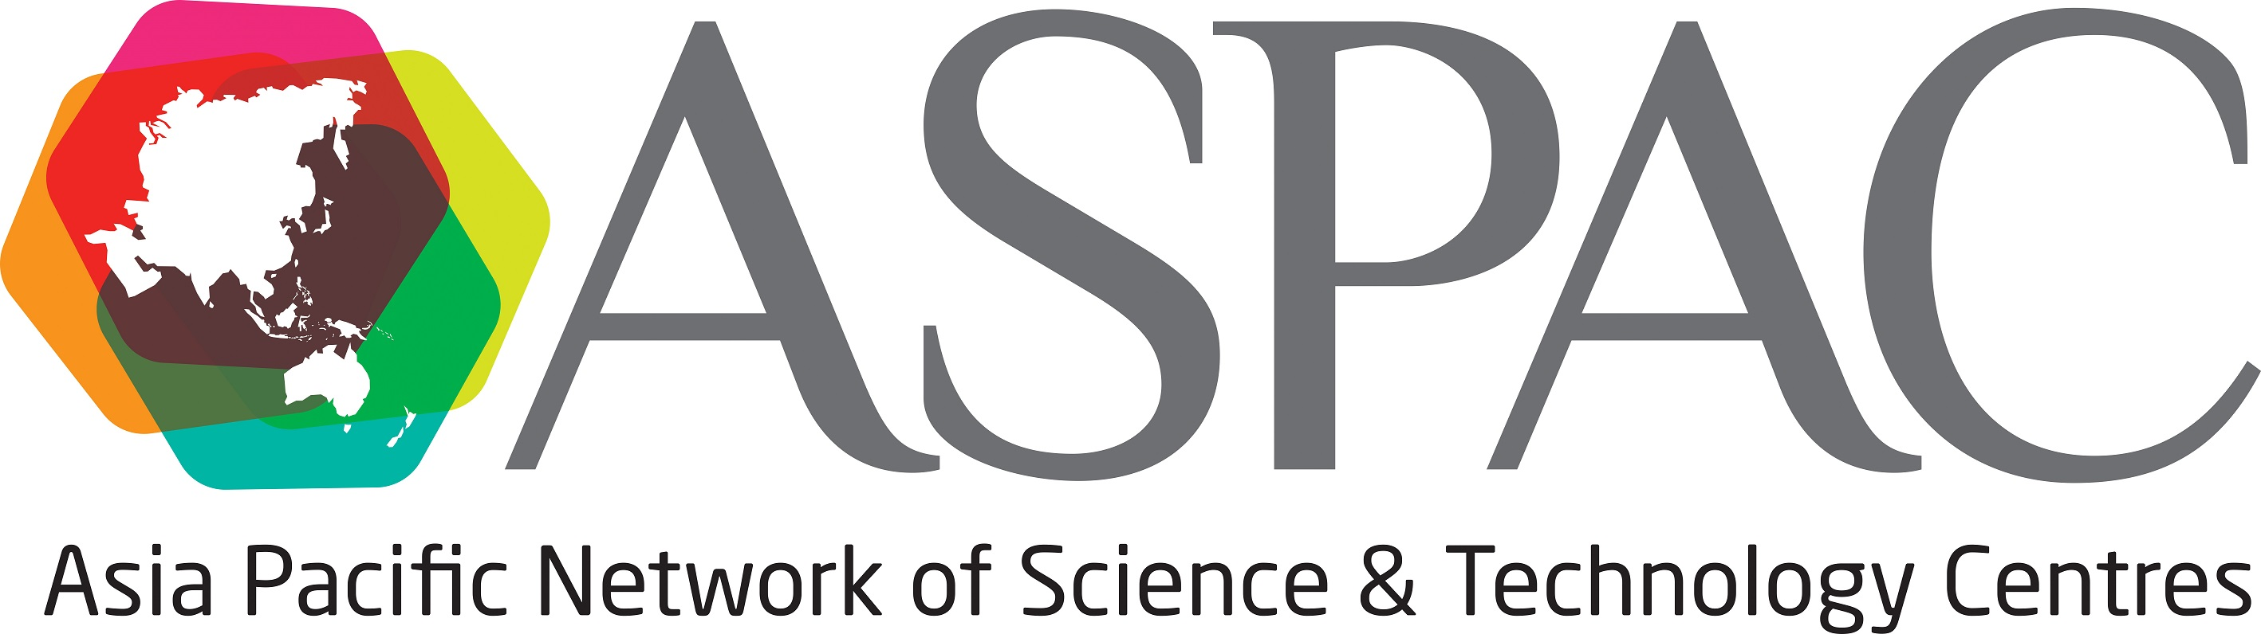
2018 ASPAC Fellowship

Application Form

Outline of the Fellowship
ASPAC is offering up to three fellowships for staff of ASPAC Full Member institutions to travel to and participate in the ASPAC 2018 conference from 5-7 September 2018 hosted by The National Taiwan Science Education Center, Taipei, Taiwan. Each fellowship provides up to US$1500 towards costs of travel, accommodation and registration.

The applicant’s proposals must describe how the fellowship will benefit not only the recipient and his/her institution, but also the wider membership of ASPAC. Fellowship recipients are required to take part in a presentation session in any of the parallel sessions of the conference, and then submit a report for publication on the ASPAC website.

The theme for this year’s conference is ‘Innovative Science Cuisine’, with the subthemes of
Day1 (5th Sep): Cooking up the Science Center Experience
Day2 (6th Sep): Knowing the Impact of the Science “Dishes” We Serve
Day3 (7th Sep): Expanding the Menu of Science Centers

This Reimbursement will be transferred to fellows after the conference.

Applicant’s Information
First Name Last Name

Position Gender

Institution

Address

Country/Region

Fax Tel

Email

Have you been a recipient of ASPAC fellowship before?
No / Yes (if Yes, in which year? )

How many delegates from your institution are expected to participate in this ASPAC conference?

Proposal Outline
Please write a statement on how the conference will contribute to your professional development and how this will benefit you, your institution, and the wider membership of ASPAC.

Supporting Reasons
Please provide a brief overview of the subtheme and the session that you would like to present at the conference.

The Reason for the Application
Please provide the reasons you need this fellowship, such as financial conditions or other pertinent issue.

Your Presentation Number and Title
Refer the website;
(http://aspac2018.ntsec.gov.tw/site/mypage.aspx?pid=162&lang=en&sid=1210)
Please indicate the session number and session title in which your presentation would fit. (i.e. 1A Expanding menu of experiences: exhibitions and programs)

Session Number:

Session Title:

Proposed Budget
Each fellowship provides up to US$1500 towards costs (including the registration fee). Please list the estimated costs of economy class air travel, ground transportation, accommodation, etc, that you will need in order to participate in the ASPAC Conference. Please list in US Dollars. (i.e. the Full Member early bird registration rate is USD $260.).

Signature of Applicant Date

This application is supported by:
Signature of Director/CEO Date

Name of Full Member Institution

Procedure and Schedule
- Submit your application for your presentation to a session by 31st May.
Please refer to the conference website (http://aspac2018.ntsec.gov.tw/site/mypage.aspx?pid=229&lang=en&sid=1210) to learn how to confirm taking part in a session and how to submit the session abstract.

- Send this completed form by 31st May in both Word and PDF formats by email to:

Rieko Chihana, ASPAC Secretary
Email r-chihana@miraikan.jst.go.jp

- The successful applicants will be notified on or before 26th June.

- Please note that in order to be eligible for the reimbursement, the successful fellows should write a one-page report, and send it together with the presentation materials to ASPAC Secretary within one month after the end of the conference (8th October, 2018). The report will be published on the ASPAC website.

- Reimbursement will be paid to the fellows upon providing the receipts for expenses.

Inquiry;
Rieko Chihana, ASPAC Secretary
Email r-chihana@miraikan.jst.go.jp

